
July 2008 Volume II, No. 3
Among Friends

Those of you who came to our yearly meeting heard of the ways that we have contributed to the Squirrel Hill Library. We have spent a lot of money and time on these additions and are very proud of the way that our group can and does aid the library.  A lie can travel half way around the world while the truth is putting on its shoes  Mark Twain  1835-1910  We will have a large book sale in July; there is a flyer for it on page 7 and Margie discusses it in her “Books, books, books…” column on page 4. We are looking for volunteers to help sell the books and keep them in order. In June, we tried to call everyone who checked “Book Sales” on their membership forms to find out who can work one or two hours during the four days of the sale. If you haven’t heard from us and want to volunteer, please call Margie at 412-521-4129 or Shirley at 412-521-7442. Our volunteer Coordinator, Anita Newell, will then call to schedule you to work alongside an experienced volunteer. It’s a good way to get your feet wet! A nice thank you for your time is that you will receive a free book when you volunteer.  The Friends meet at 10 a.m. in the library on the first Saturday of every month except August and any member can attend. I look forward to seeing you more often in the library, at our meetings and at our sales.
  Thank you for electing me your new president. I am pleased that we are adding new members to our group and trust that you will help us in our task of adding new resources to our library. | PRESIDENT’S  MESSAGE  by  Joan Schwartzman | 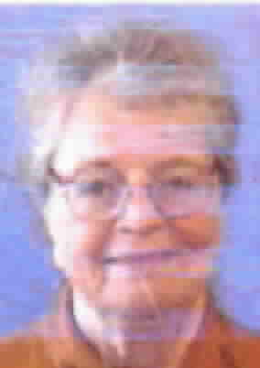
  WELCOME,
  NEW MEMBERS
  Eleanor Bernstein
  Marc Bini
  John Brody
  Mary Clare Bunce
  James Busse
  Barbara Coffey
  Diane Cohen
  Julie Crolius
  Scott Dewald
  Valerie Doll
  Yanping Dong
  Jean Dubowitz
  Faye Fischman
  Danielle Hamel
  John Henry Harrison
  Barbara Jones
  Pat Kimbrough
  Betty Margolis
  Karen Peterson
  Jennifer Phillips
  Anne Marie Rooney
  Joy Sabl
  Christina Sahovey
  Neal Scoratow
  Doug Shields
  Shirley T. Shratter
  Keith Turek
  Therese Van Arsdale
  Eric Webber
  Robert White
  Marie Williams
  Fred Zuhlke
CORRECTION  In our last edition, we mis-stated the Finegold family's name. We regret this error. Here is how the article should have been printed.  Ax  xw.  Ax  ####  ➔ | 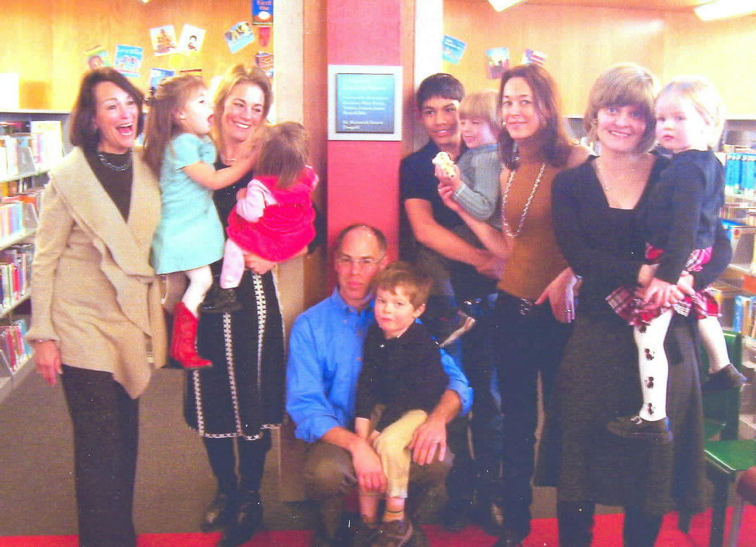 | A very pleasant event occurred in the children's section on February 3, 2008. There was a dedication of a plaque commemorating a donation from the Finegold family in honor of their  grandchildren. This is a particularly lovely thing to do in memory of a loved one and we all appreciate Marian Finegold (at left in the picture) and her family for this donation.

Published by the Friends of the Squirrel Hill Library 5801 Forbes Avenue Pittsburgh, PA 15217
website: www.clpgh.org/locations/squirrelhill e-mail: Friends@pittsburghusedbooks.com
editing: Joan Schwartzman production: Margie Spenser, Marion Damick, Serena Spenser mailing list: Margie Spenser

July 2008 Among Friends Volume II, No. 3
July 2008 Among Friends Volume II, No. 3

  Art at the  Squirrel Hill Library  ----------------------------------------------------------  Coming up are:  July: Jeanne Wiggins  mixed media  August: Barbara Coffey  watercolors  September: Eric Rosen  photos  Our schedule for artists is full through August, 2009! If you are interested in exhibiting after that, contact Marion Damick,  412-521-3075. | that kids are reading and listening to this summer. If you haven’t already signed up for summer reading, hop into the library or jump online at www.carnegielibrary.org/summer to “Catch the Reading Bug”! You will receive a folder in which you can keep track of each book read, and/or the time you spent reading. You can also keep track on the website by using your login and password. Kids can also collect insect trading cards this year. Stop by the library each week to get your bug of the week card.  On Monday, June 30 at 6:00 p.m., join us for Doc Dixon’s Catch the Reading Bug Magic Show. Doc performed for us during last year’s summer reading club and kids are still talking about the amazing tricks he did. Just like last year, this year’s show will feature a special appearance by Butch, the psychic bunny! You won’t believe your eyes! Check out the website at www.carnegielibrary.org/events for more information about these and other exciting events.  Take me out to the ballgame! Tuesday, July 29 is library night at PNC Park. The Pirates have offered a $6.00 ticket price for this event. A family of four can attend this game for $24.00. Game time 7:05 p.m. Stop in at the library to pick up an order form for the tickets. Now that’s a great deal!
  Catch the Reading Bug @ Your Library  by Erin Scioli  Children's Library Assistant  Dragonflies, grasshoppers, and butterflies, oh my! Summer reading is well underway at the library. We’re having lots of fun learning about all of the good books | 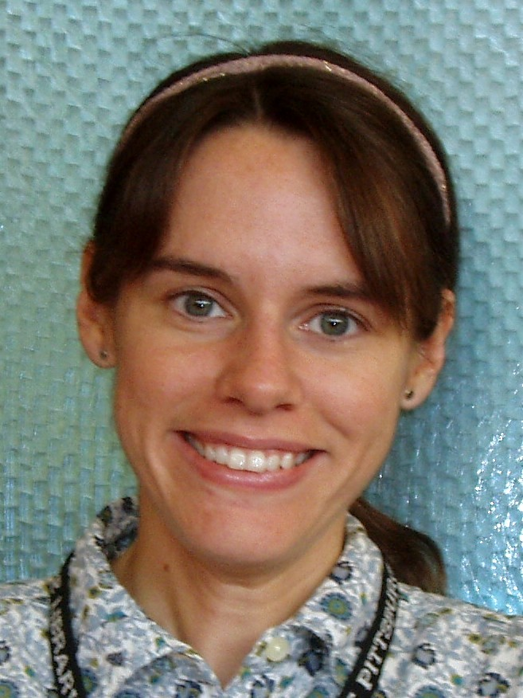
One Artist's View  What fun it is to draw and paint flowers!  I am happy to be exhibiting my art at the Library during the month of August.  I was an art teacher and art therapy specialist. I am a member of the Pittsburgh Association of Art in Education and Therapy, the Colored Pencil Society, and the Fiber Arts Guild. I am also a Carnegie Museum of Art Docent and I belong to the American Society of Botanical Artists and the Greater Pittsburgh Arts Council.  Sincerely,  Barbara Coffey |  | To keep your secret is wisdom;  to expect others to keep it is folly.  Samuel Johnson  1709-1784
  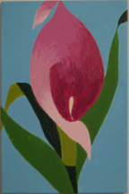 | Recently I returned to taking painting and drawing classes at Pitt and Phipps Conservatory, whose fabulous teachers started me on my enjoyable quest to photograph and paint nature.  It was a pleasure to paint these flowers, and I hope you enjoy them as a background to your library experience.
  METAMORPHOSIS
  by Kim Parker
  Teen Librarian
  This year's Teen Summer Reading theme is Metamorphosis @ Your Library, and we are metamorphosizing some things here at Squirrel Hill. This summer we are using crafts to transform everyday objects. In June the teens metamorphosized their flip flops with fabric, balloons,sequins and trim.
  On Saturday, July 12th we'll metamorphosize tank tops into beach bags, and on Saturday, August 2nd look for some duct tape to metamorphosize into flowers. Both events will take place from 1 to 2:30. | 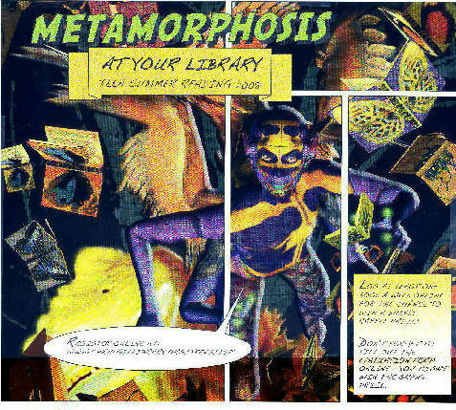
2

July 2008 Among Friends Volume II, No. 3

See what your Friends  have been up to  On June 1st, the Friends of the Library held the Annual Meeting mandated by our By-Laws. It included a special program and a brief business meeting to elect officers (see page 7) and to report what we have done during the past year.  As the last duty of her term, President Marion Damick listed some of the things we have bought for the library, such as 40 adjustable computer chairs and two more display units for Audio/Visual items. The branch manager, Librarian Holly McCullough, reviewed the sources of library funding. Although the Pittsburgh Carnegie Libraries are the chief recipient of the extra 1% sales tax in Allegheny County and we receive some state funds and donations, there is never enough money for everything the Squirrel Hill branch needs. The Friends help greatly with filling the gap, paying for not only furniture but books, tools, office supplies, Summer Reading program items, and various other odds and ends like a teacher for the Chess Club.  Our special program was a demonstration by Penny Layne from "Paws With a Cause", an organization that trains assistance dogs for the deaf, the physically challenged, and people with seizure disorders. Her demonstration dog, Fawn, turned on lights, pulled open doors, picked up dropped items, spread a blanket over a person without use of her arms, and fetched specific items on command, with enthusiasm and amazing discipline.  One reason our bylaws call for an Annual Meeting with a special program is that we want to attract new people to our monthly meetings. At those meetings we discuss all sorts of library events and problems, and act as a sounding board for the library manager. We also find out what's on her Wish List, learn whom we should be contacting to urge more support for libraries, and work out the details of our fund-raising efforts. Come help us!  Join us at our regular  Friends Meetings:  Saturday July 5  at 10 a.m.  Saturday Sept 6  at 10 a.m. | Film, Fiction, and Fun is a special series presented at the Carnegie Library of Pittsburgh, Squirrel Hill that  July 17th’s novel is Howard’s End, by E.M. Forster. This classic story depicts turn-of-the century England’s class struggles through the interaction of three families, the Wilcoxes, the Schlegels, and the Bests. The 1992 film, directed by James Ivory, won 3 Oscars and stars Emma Thompson, Anthony Hopkins, Vanessa Redgrave, and Helena Bonham Carter.  August 21st’s selection is The Old Man and the Sea by Ernest Hemingway. This short novel is an ageless tale of man against nature, and it is largely considered the tipping point for Hemingway winning the Nobel Prize in 1954. The 1958 film was directed by John Sturges. Despite the fact that Hemingway said that he looked less like a Cuban fisherman and more like "a rich old actor,” Spenser Tracy received an Oscar nomination for the title role.  September 18th’s title is Mephisto, by Klaus Mann. In this 1936 novel, a Berlin actor takes the role of the devil in a Faustian play and ends making his own pact with evil as he achieves acclaim from the Nazi party. The Hungarian-produced 1981 film won the Oscar for Best Foreign Language Film.  Forthcoming Film, Fiction, and Fun:  October 16th: Beloved, by Toni Morrison  December 18th: Intruder in the Dust, by William Faulkner
  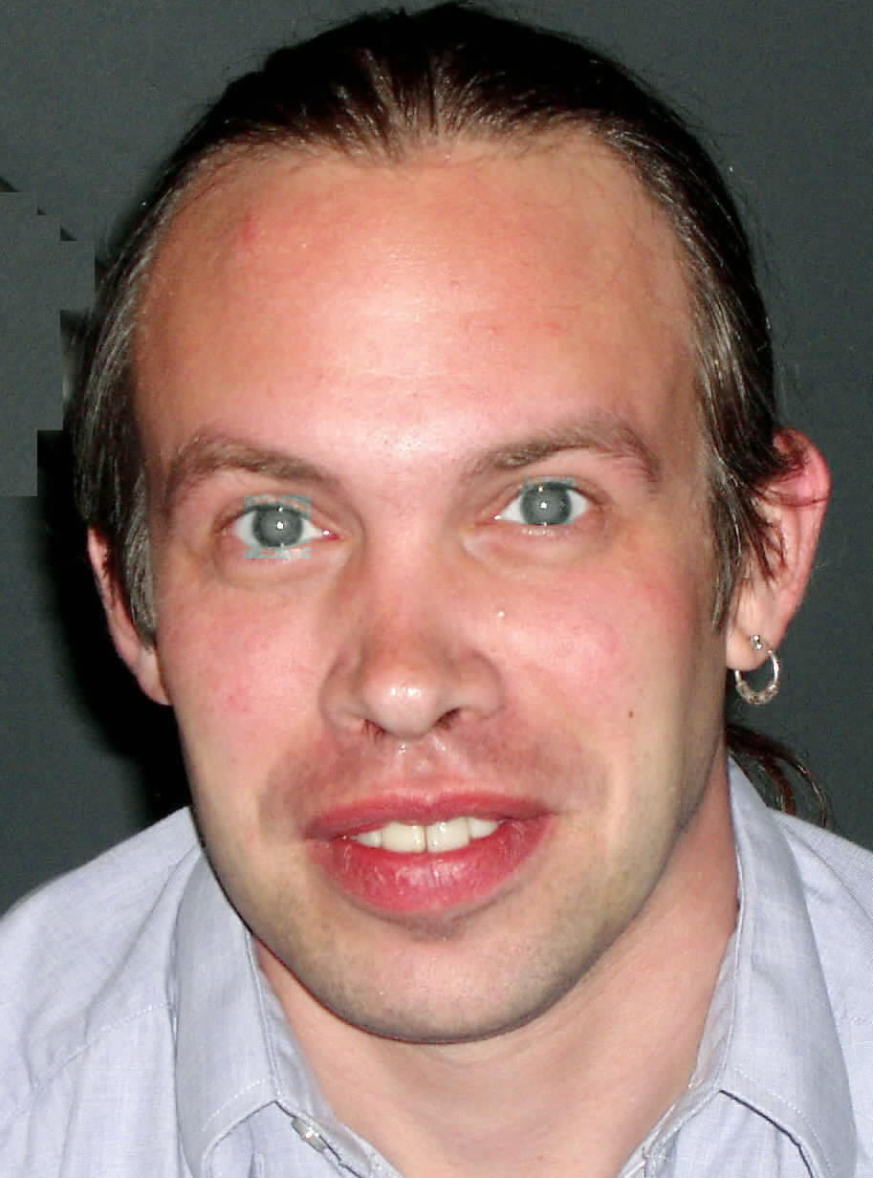   | Film,  Fiction, and  Fun – | 
  third Thursday of the month
  from 1 to 4 p.m.
  explores the relationship between films and the novels that inspired them. Attendees are encouraged to read a monthly fiction selection, and then join CCAC’s Jeanne Bergad for a screening of the film and discussion to follow. | 
  THOSE WHO CANNOT REMEMBER THE PAST ARE CONDEMNED TO REPEAT IT.
  GEORGE SANTAYANA
  1863-1952

3
July 2008 Among Friends Volume II, No. 3

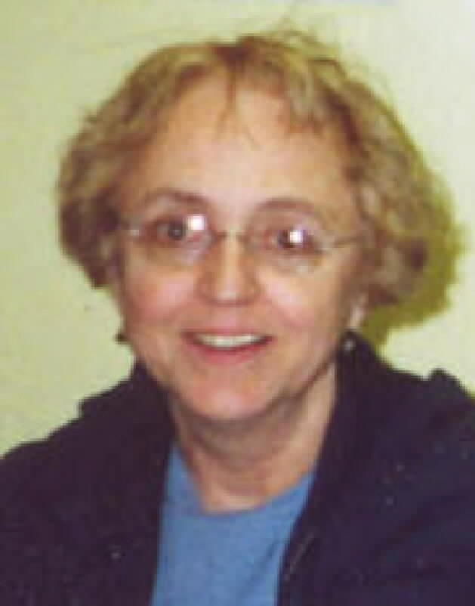  by Pat Bender, mini-sale chair | MINI SALE NEWS  To our delight, May's mini-sale of travel, humor and classics earned $550. The FOL Boutique earned almost $100. This amount is the most the boutique has earned to date. Your support is very gratifying.  While there won't be another mini-sale until September, the FOL Boutique will be part of the July sale. As the seasons have changed, the boutique has expanded to include more kinds of items. For July we have added cotton knit items - necklaces,
bracelets, belts and string scarves. There will also be a variety of button jewelry styles such as string necklaces and bracelets. We will have some new styles of bookmarks and the fun items the kids enjoy so much.

Religion is the focus of the September mini-sale. Our entire holdings of Judaism, Christianity, Eastern religions, philosophy and spirituality will be offered. As always, we will have a wide selection of non-religious Judaica available as well. You may notice on the flyer on page 8 that we are opening the sale at noon on Friday to accommodate our Orthodox Jewish customers who have asked to have time to shop before sundown.

BOOKS, BOOKS, BOOKS, BOOKS, BOOKS, BOOKS, BOOKS,BOOK  Getting ready for our celebration of the 50th anniversary of National Library Week in April taught me a lot about libraries; I had planned to post many handouts about reading and libraries and Friends groups but as usual, I bit off more than I could chew. I didn't get most of the handouts posted on the wall until the very end of the sale;a few even remain to be written. Next year, though, I'll be ready with lots of printouts of what I learned! I welcome suggestions of things to share with all our fellow readers. |  | 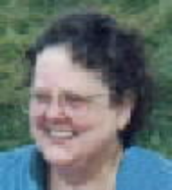  by Margie Spenser  Book Sale Committee
Some things went as I hoped: the Spring Cleanup Sale we held during the celebration recycled a lot of used books and and earned us more than $1670. And I found out the rest of the story about August Wilson that I recounted in my last column. It was true that he dropped out of Gladstone when a teacher said he'd plagiarized a 20-page paper about Napoleon, and that he then educated himself at the library, which lead to him being issued a diploma by the Carnegie Library of Pittsburgh.. It was an honorary diploma, of course, awarded to him at the 1999 centennial of the Hill District Library, where he gave a remarkable speech about reading, Feed Your Mind, the Rest Will Follow**. He explained that he had gone to the library every day because he didn't dare tell his mother he had left school. (Duh!) At the library he discovered books by black authors as well as history, sociology and many other things that enlarged his view of the world. Libraries truly are "the memory of the human race" and one of the biggest sources of hope for its future.

SUMMER SALE: We are having our big Summer Fiction Sale on July 17-20, during the Squirrel Hill Sidewalk Sale and the day after. Our corner should be a fair all by itself; we are going to have a piano player demonstrating the wonderful old sheet music we will have for sale, Remember those old movies about the song writers and musicians of Tin Pan Alley? There was always at least one scene with the hero playing a piano in a music store while a beautiful young female customer sang along. Judy Garland can't be there, but we'll still have fun. Pat Bender will have more of her wonderful jewelry and some new items. We'll have all our Foreign Language and A/V stuff out, too, as always.

Over the last five years, we've had several drawings for wonderful crocheted afghans. Each time, we have been able to thank only a "generous anonymous donor". Finally, we've persuaded her to let us thank her publicly for her latest donation (see page 7.) Thank you very much, Mary Steiner!

Mary is a talented artist and crochet teacher who particularly enjoys using her craft for others. She currently heads a crochet group at Oasis in the downtown Macy's store from noon to 3 every Friday (except the first Friday of the month). It's free to all, at any level of skill. Just bring your yarn and your hooks. You'll find a congenial group of people who are working on their own projects as well as things for the clients of Meals on Wheels, with informal teaching from Mary if needed. She even invited me to come knit and chat!

** for the complete text of Wilson's speech, go to http://search.post-gazette.com/Default.asp and put "March 28, 1999" in the search box – including the quote marks. Then scroll down and down to the link.
4

July 2008 Among Friends Volume II, No. 3
 | All programs are scheduled for Wednesday  from 10:15 AM-11:00 AM  Wednesday, July 16 -- Whether it’s family issues involving visitation & divorce; housing problems including wrongful evictions & mortgage foreclosures; or other personal financial crises, hear about the assistance available at Neighborhood Legal Services.  by Frank Pistella, Attorney,  Neighborhood Legal Services  Wednesday July 23 -- Global investing: Learn about how to use global mutual funds to help diversify your portfolio, reduce volatility, and possibly increase your rate of return.  by Aaron Hayes, MBA, Investment Consultant,  Harvest Financial Corporation  August -- no programs  Wednesday, September 17 -- Women Re-entering the Workforce: What Do I Want to Do and How Do I Get There?  by Karen Litzinger, MA,  Litzinger Career Consulting  as an abolitionist, a strong advocate for women’s suffrage, and a voice for social justice.  Douglass was born a slave. In his 1845 autobiography, “Narrative of the Life of Frederick Douglass, An American Slave”, he stated that he learned to read when he was about 12 years old.  On 9/3/1838, at the age of 20, he escaped slavery dressed in a sailor’s uniform and carrying identification papers provided by a free black seaman. He reached New York and then continued traveling to New Bedford, Massachusetts.  He traveled extensively and while he was in England in 1846 British sympathizers collected 700 pounds to purchase his freedom from his slave owner.  From 1877 until his death in 1895, Douglass lived at the estate he called Cedar Hill, located in the Anacostia neighborhood of Washington, D.C. Daily tours of the Douglass Home are offered and a visitor center provides an orientation film, exhibits, and a bookstore. Dedicated June 24, 2007.
  NAMM BUSINESS CENTER PROGRAMS  July - September 2008  by Dorothy Kabakeris,  Namm Business Center Librarian | 
   | The Frederick Douglass National Historic Site preserves the last residence of Frederic Douglass (1818-1895), one of the most prominent African-American leaders of the 19th century. A fiery orator, dedicated editor, bestselling author, and presidential advisor, Douglass crusaded for human rights
The Squirrel Hill
Adult Book Discussion Group
meets on the last Thursday
of the month from
1:00 PM to 2:00 PM.

All are Welcome.

July 24
The Sisters; the Saga of the Milford Family
by Mary S. Lovell, 2002

August – no meeting

September 25
A Moveable Feast
by Ernest Hemingway, 1964
When I despair, I remember that all through history the way of truth and love has always won. There have been tyrants and murderers and for a time they seem invincible, but in the end, they always fail -- think of it, ALWAYS.
Mohandas K. Gandi
1869-1948
The monthly Namm newsletter lists our business programs, highlights a key business database each month, and offers a compilation of new business titles. If you are interested in receiving it, email us at: squirrelhill@
carnegielibrary.org

5

5

July 2008 Among Friends Volume II, No. 3 July 2008 Among Friends Volume II, No. 3
Read any Good Books Lately?  Summer has arrived and with it, hopefully, wonderful weather and more free time with family and friends. Summer is also the time for Summer Reading Clubs. The library has separate programs for children, adults, and teens and can offer rewards for even the occasional reader. Make sure that everyone in your family is signed up for one of our programs.  If you're looking for light and casual reading this summer to take to the beach or just as you lounge on the porch, we have plenty to offer. From travel books to help your planning, audio books you can listen to on your way there, and paperbacks or magazines that are great for the suitcase or the sand, we’ve got it all. If perhaps high gas prices are keeping you close to home, then reading offers the cheapest escape you can imagine.  Not sure what you want, or need some suggestions? Perhaps you’re not aware of our Reader’s Advisory service. Our librarians have a wide knowledge of what we have and love talking about great reads. Stop by or call us and we’d be happy to offer some recommendations to suit your mood. We also regularly create new topical book lists and displays to help you discover your new favorite author or book. | gave me and know they will be just as supportive for the new president, Joan Schwartzman.  I remember the great Annual Meeting programs we had, featuring Post-Gazette speakers, a magician who fascinated the children, and this June 1st, Penny Layne and her dog Fawn, who demonstrated how much assistance dogs can do for people with disabilities.  Our membership has grown, and because of it, and the large profits from our frequent book sales, we have purchased an amazing array of items for our own library! I bet all the other branches envy us.  It makes my heart warm when I see the many children and teens reading and utilizing the library. That is something that will last them throughout their lives. We must do everything we can to encourage this.  So – as I help with the book sales, handle the art exhibits, check the shelves for large-print books for my husband – I hope to see you and to say "hello".
  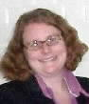 | By Holly McCullough, Manager,  Carnegie Library of Pittsburgh –  Squirrel Hill
  I'm Still Involved  by Marion Damick  Even though I'm no longer officially President of the Friends, I still hope to remain involved with the daily activities. I can look back on the tremendous help that all the librarians, especially Holly and Audrey, | 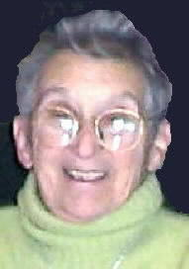
  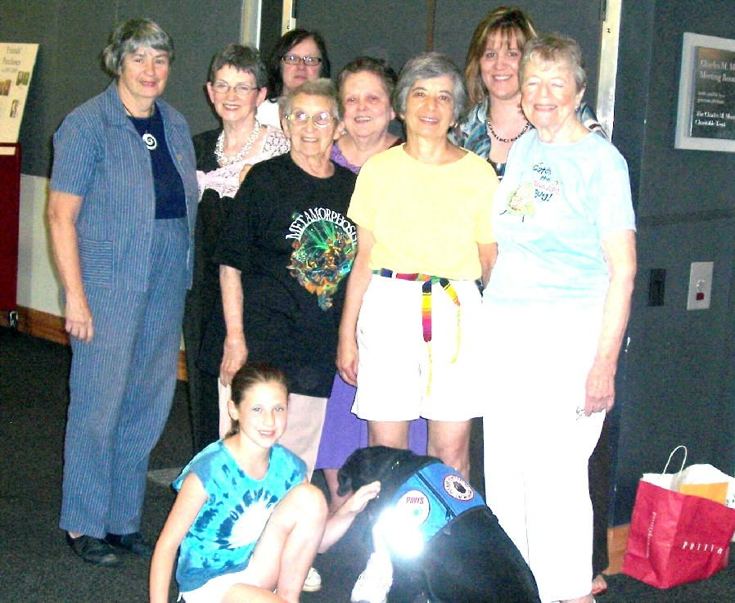 | Back Row: Friends Marilyn Honigsberg, Shirley Streff, Judi Galardi, Margie Spenser and guest speaker Penny Layne from "Paws With a Cause".  Middle Row: Marion Damick, Eleanor Herschberg, Jane Schwartzman.  Front Row: Penny's niece/special assistant and Fawn.
  Congratulations  to Frank DePietro, winner of the  May 18th drawing for the beautiful art book.  We sold 132 tickets.  Our thanks to the anonymous donor. | 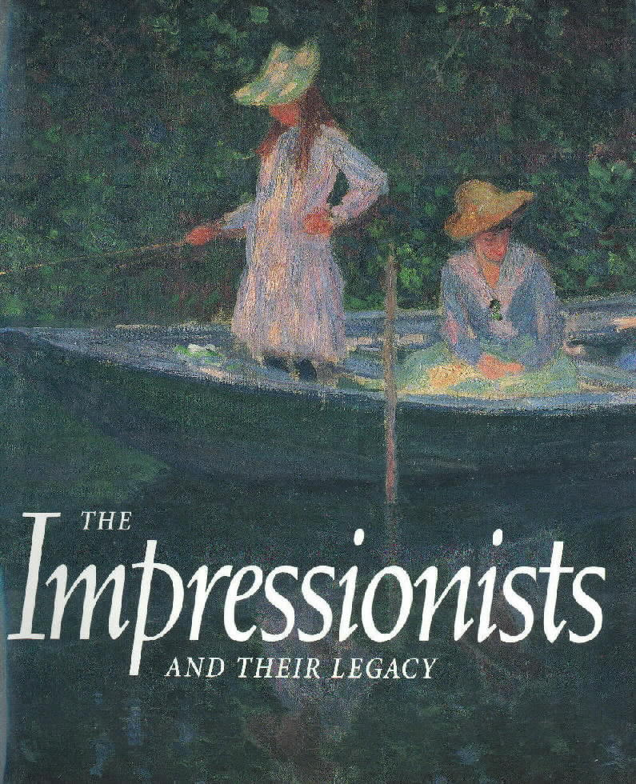

Meet Some Important People:
watch for more in the next issue
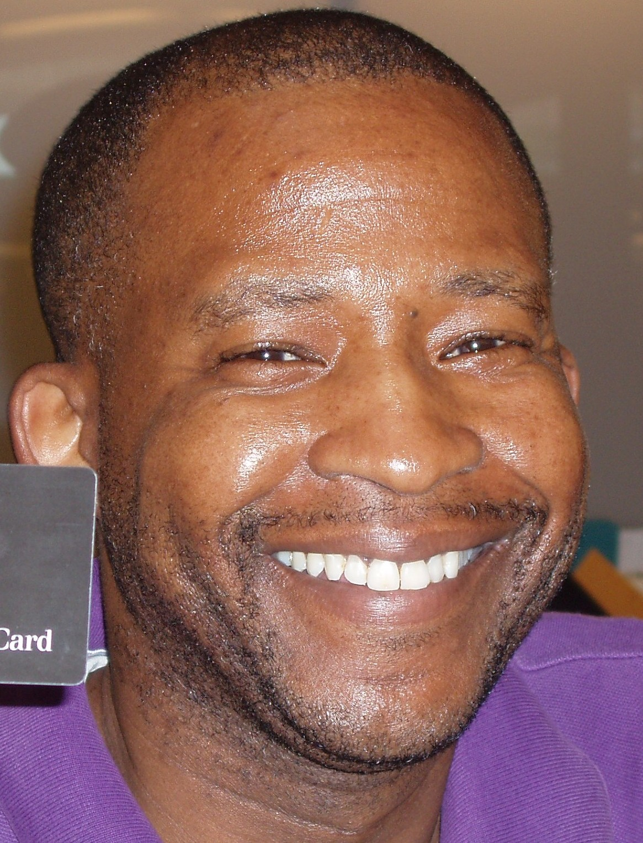  Dwayne Robinson  Clerical Supervisor | 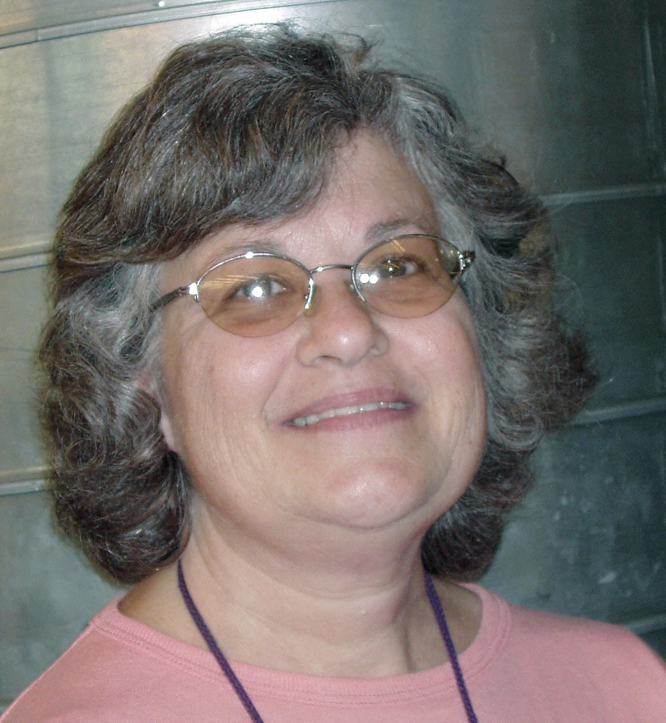  Susan Hughes  Sr. Children's Librarian | 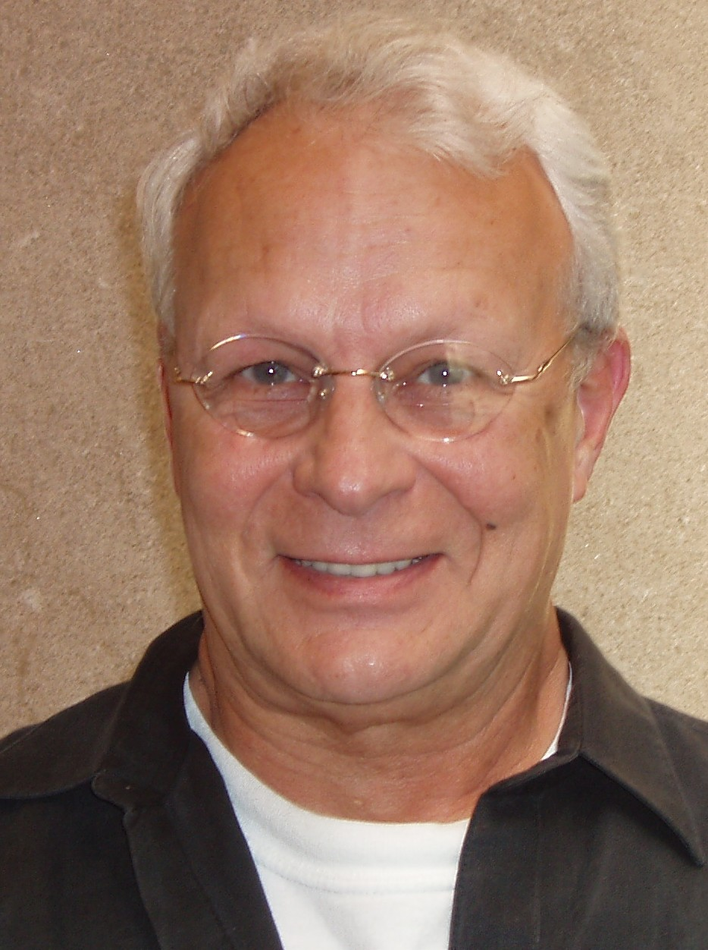  Frank DiPietro  Security Guard | 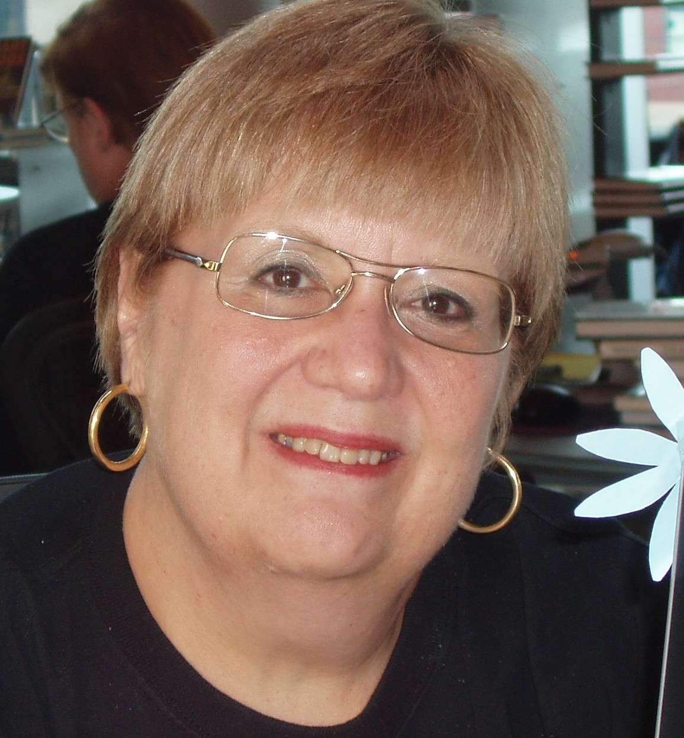  Mary Anne Singer  Librarian | 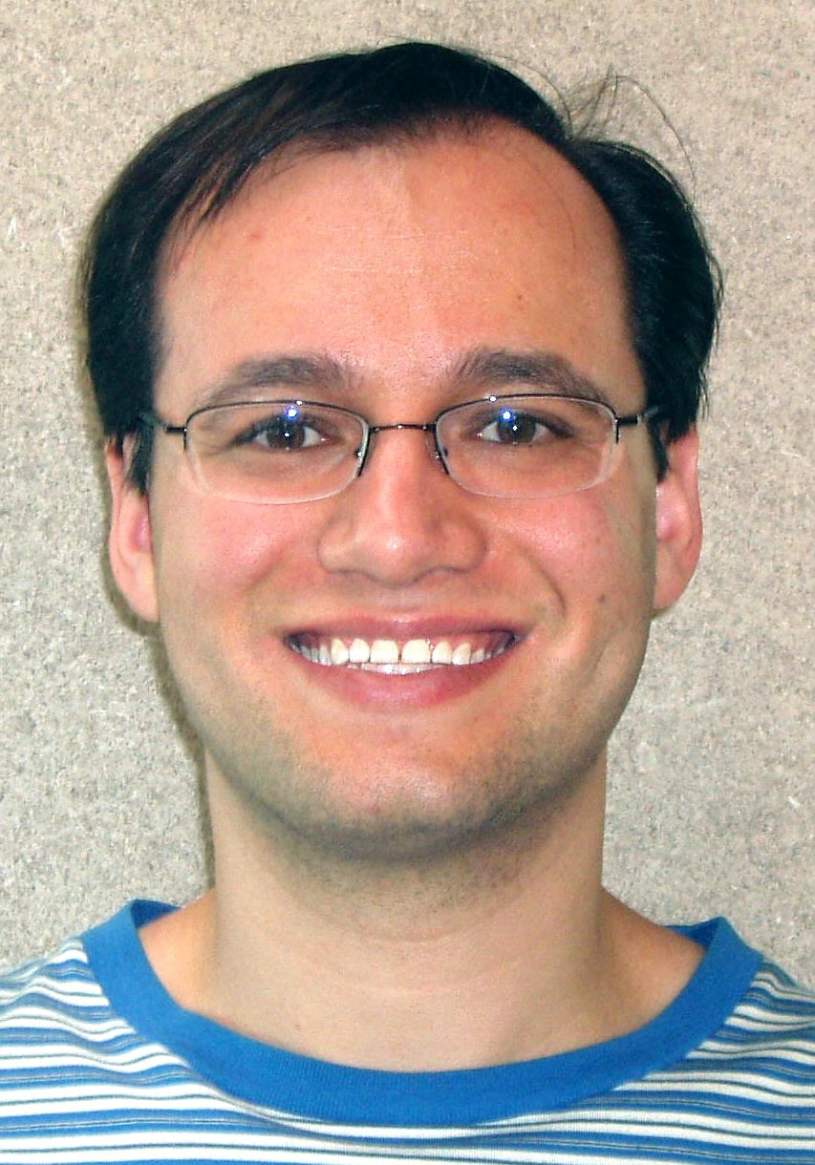  Adam Brody  Clerk
6

July 2008 Among Friends Volume II, No. 3

New Friends Officers  Joan Schwartzman President  Marion Damick Vice President  Eleanor Hershberg Treasurer  Shirley Streff Secretary  write us at  friends@pittsburghusedbooks.com | SUMMER FICTION/  FOREIGN LANGUAGE/A-V  BOOK SALE  Thurs July 17th thru Sat July 19th  10 a.m. to 4:45 p.m.  Sun July 20th 1 p.m. to 4:45  Bag Sale $4 (hardbacks)
  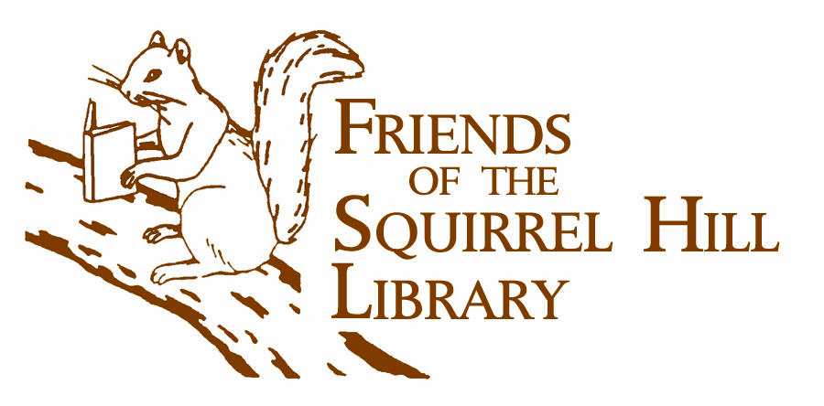
  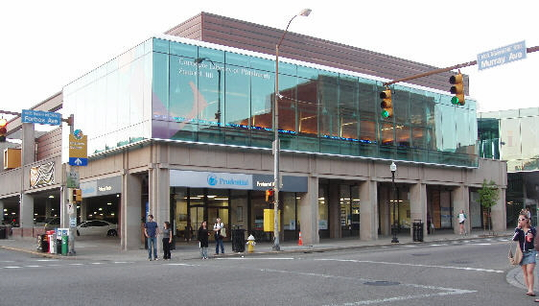  Squirrel Hill Library  5801 Forbes  412-422-9650 | LIVE MUSIC!  We have a marvelous collection of sheet music  donated by Eric Marchbein for sale, and a keyboard donated by John Henry Harrison. We’ve  got a musician coming, and we need
Paws With a Cause is celebrating
THE DOG DAYS OF SUMMER
The Waterfront -- 1-3pm

July 19th (PAWS Graduation)
and
August 9th

Musical entertainment and doggie games in the courtyard at Starbucks.

BRING your families and your DOGS!!!
Friends Used Book Sales

July - Summer Fiction/Foreign/A-V
and a special sale of vintage sheet music
during the Squirrel Hill Sidewalk Sale

August – no sale

September – Philosophy/Religion & Judaica Mini Sale

for sales elsewhere, go to www.pittsburghusedbooks.com

You Could Win  this beautiful afghan  handcrafted by  Mary Steiner  Buy chances for $1 at the Customer Service desk  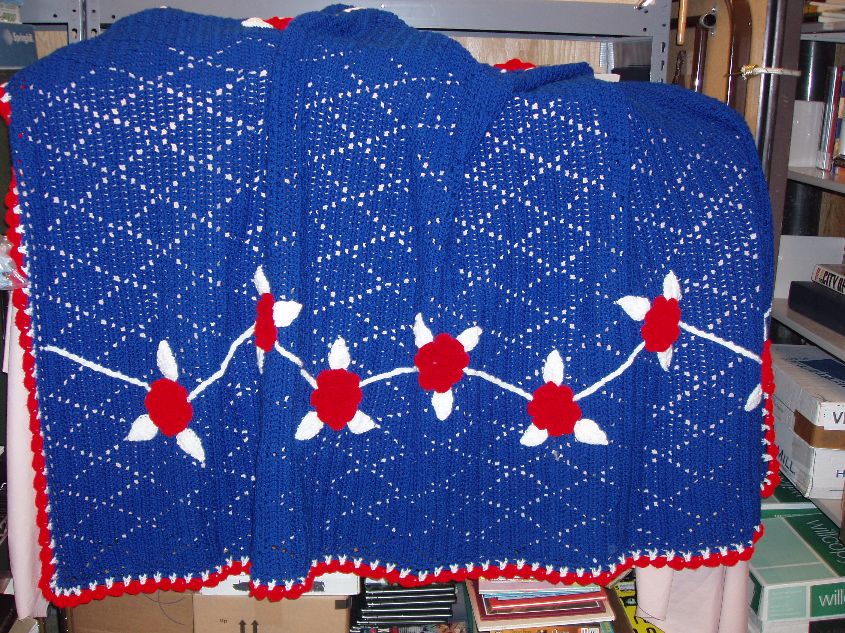  The drawing will be held at the Summer Fiction Book Sale  on Sunday, July 20  at 4 p.m.  Winner need not be present. | Cut along the lines on the back for a reversible flyer.  If you can post a full-sized flyer at work, at school, etc., pick one up at the service desk at the library. They're available starting three weeks before each sale.
Famous science fiction author and science writer Isaac Asimov had this to say about our favorite place:
I received the fundamentals of my education in school, but that was not enough. My real education, the superstructure, the details, the true architecture, I got out of the public library. For an impoverished child whose family could not afford to buy books, the library was the open door to wonder and achievement, and I can never be sufficiently grateful that I had the wit to charge through that door and make the most of it. Now, when I read constantly about the way in which library funds are being cut and cut, I can only think that the door is closing and that American society has found one more way
to destroy itself.
— I, Asimov. New York:
Doubleday, 1994
Have you paid the Carnegie Library $30 or $50 for a Donor Card? Then you are the kind of patron – involved, supportive – we'd like to have in our Friends of the Library auxiliary. So we are waiving the fee for your first year's membership.

Just fill out the form on the next page.
(And yes, we are happy to accept a donation.)

The Friends of the Library raise money to supplement the budget of our branch library

The Friends of the Squirrel Hill Library
5801 Forbes Ave. Pittsburgh, PA 15217
www.clpgh.org/locations/squirrelhill

Between the optimist and the pessimist,
the difference is droll
The optimist sees the doughnut;
the pessimist the hole.
Oscar Wilde 1854-1900

7

July 2008 Among Friends Volume II, No. 3
Philosophy/Religion & Judaica  BOOK SALE  Fri Sept 19th noon to 4:30 p.m.  Sat Sept 20th 10 a.m. to 4:30 p.m.  Sun Sept 21st 1 p.m. to 4:30 p.m. | Make checks payable to:  Friends of the Squirrel Hill Library  and mail to:  Margie Spenser  5900 Douglas St  Pittsburgh, PA 15217  Check one box:  New Member Renewal  Check one box:  $3.00 $5.00 DONOR (free)  $10.00 $25.00 Other _____  Name:___________________________________  ^{(Last)} (First) (Initial)  Address: _________________________________  City/State: __________________Zip: __________  Phone(s): ___________________Date: _________  E-mail address: ____________________________  Please check all activities you can help with:  Periodic Book Sales Sorting Used Books  Adopt-a-Shelf Program Gardening  Library Advocacy Newsletter/ Mailings  (lobbying, writing letters)  COMMENTS_________________________  _________________________________  _________________________________  _________________________________
  Squirrel Hill Library
  5800 Forbes 412-422-9650800 Forbes 41212-422-9650

Is your Friends Membership up to date? Please check your mailing label/membership card, below. If the date is before 07/08, you need to renew. If you bring this page to one of our Used Book Sales, you'll get a free book with your renewal. Or mail us the form above.
your donation is tax deductible as a charitable contribution
CARNEGIE LIBRARY OF PITTSBURGH  SQUIRREL HILL  5801 Forbes Avenue  Pittsburgh, PA 15217 |  | NON-PROFIT ORG.  U.S. POSTAGE  PAID  Pittsburgh, PA  PERMIT No. 307
Adult Services: 412-422-9650  Children's Services: 412-422-9841  Fax: 412-422-5811  www.carnegielibrary.org/clp/sq  membership card | ADDRESS SERVICE REQUESTED  8
  
  EXPIRES:  Month YYYY | NAME  ADDRESS  CITY, ST

